Website
- There is no kapcha when it comes to logging in and/or creating a new user. 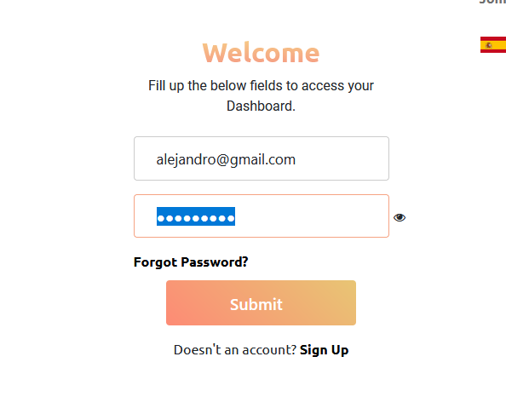
- There is no check to see if it is valid mail or if the email exists when creating a user. For example, we create a new user, without accepting the terms and conditions.
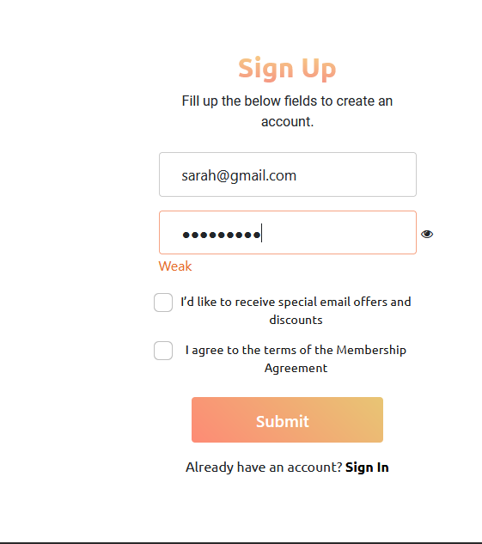

Later it asks us for a supposed code sent to our email, supposedly, if we don't put the correct code it shouldn't let us continue, but we click Sign In
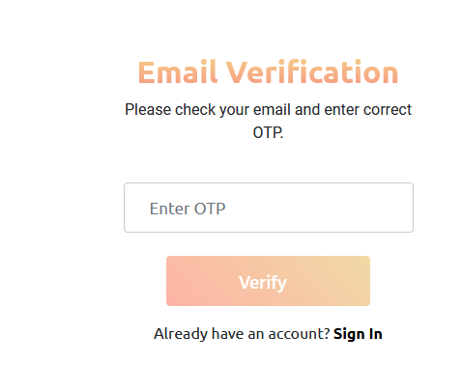

And we can enter the page already logged in, that is, the supposed code was not needed.
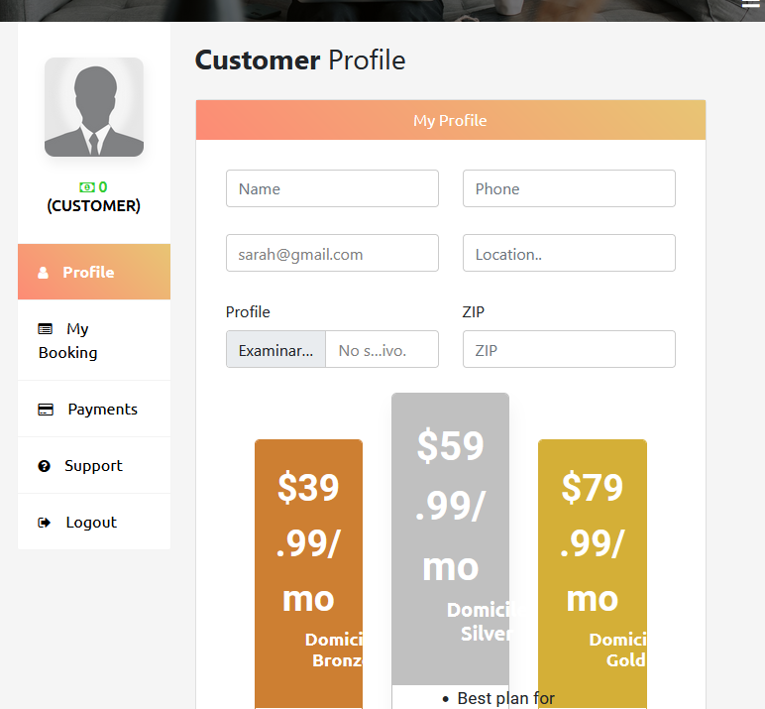
- There is no email confirmation for new users. The user should not be created and/or made permanent until confirmation is received, after a period of time, 1, 2 or more days without receiving it, it is automatically deleted. Otherwise, we will have thousands of created users who are real to us, and if they make us a Bot to create only users, we will be victims of a DoS.

- Page language switching doesn't work. Even if we put the language in Spanish, we get things in English.

- After creating a user, there is no place where they can change their password, which must happen with confirmation by email or pin to the cell phone, the same idea can be implemented for the creation of new users, as does What'sApp or Telegram, the latter is just an idea.
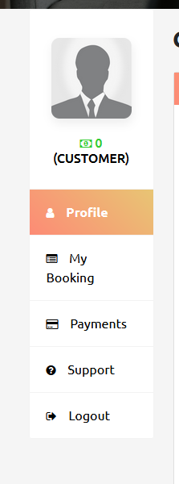

-----------------------------------User Dashboard ----------------------------
- There are spelling errors, one of them in My booking, in the user profile.
- The Subscribe label at the bottom of the page doesn't work or at least doesn't generate anything when you put an email and click on the button, it should check that the address is valid and give some kind of visual information that everything was ok or that an error was generated.
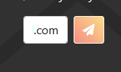

--------------------------------------------------Administrative Dashboard -------------------------------------
- When reviewing existing users in the Dashboard, the creation date is 400 years ahead.
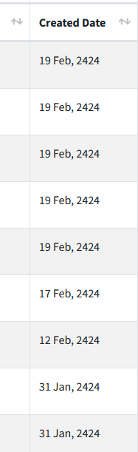
- It's the same with all the other dates, they're 200 years in the future.
- Booking Details doesn't open images in expert and customer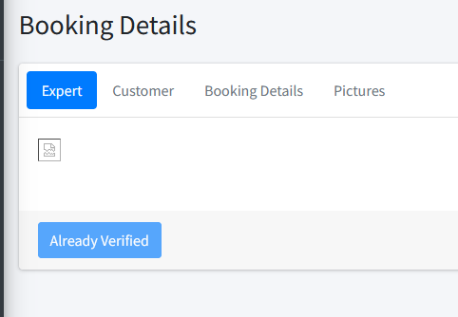
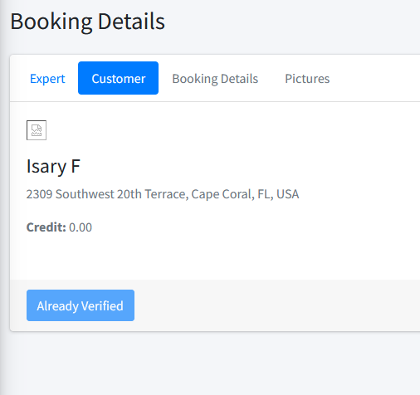

- In Booking Details pending verifications, which the Verification Pending button does, it pulls up a window that says Is review done from your side?, it allows us to give it Approve but it doesn't do anything, is that okay? I think I should pass it to Admin Verified. If so, you're not.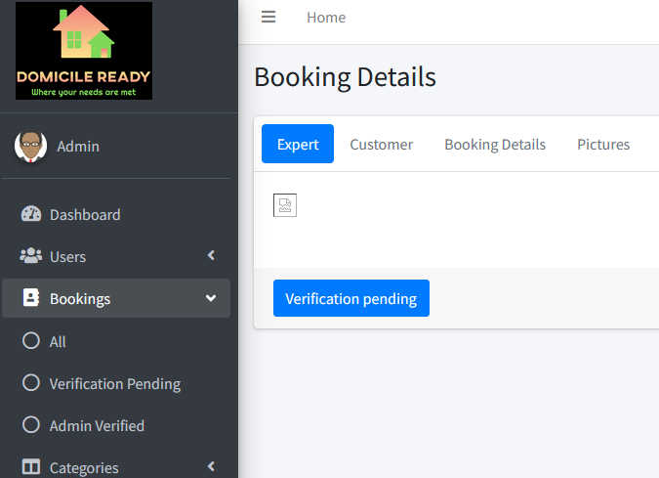
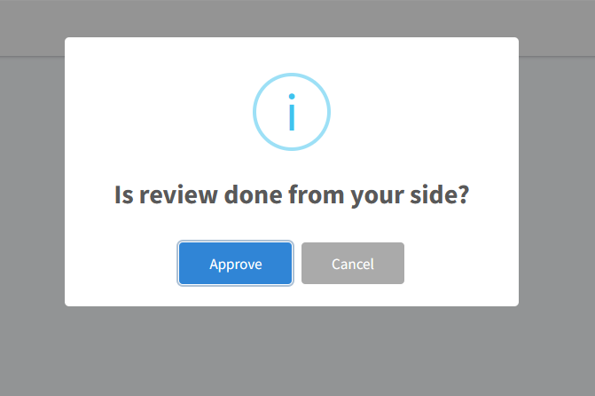

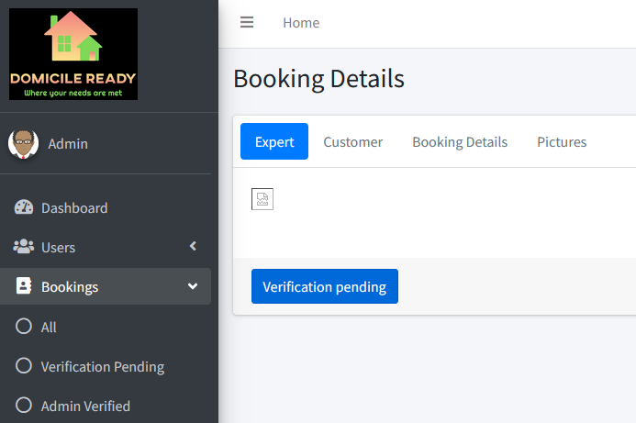

- At the bottom of the page, in the Copyright, the Domicile Ready link doesn't work.
- In Pictures of Booking Details, you should let enlarge the images that appear, now it doesn't.
- In Category , editing an existing one doesn't load the preview of the images.
- There are no filters in Category other than All, or it is removed and left only Categories, or specific categories are added.
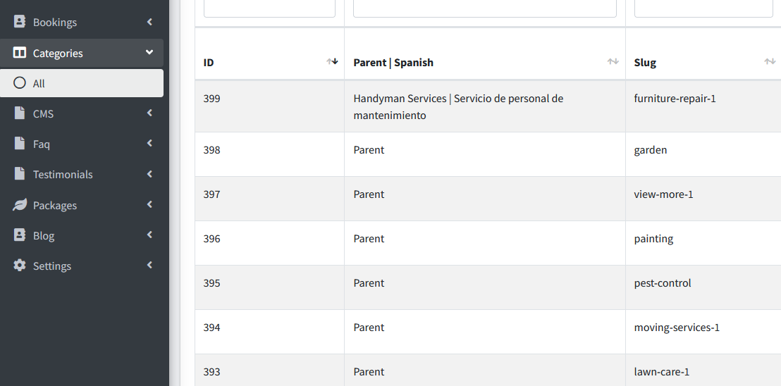
- In Package, the existing packages were created in 2020, and they say that they only last one month, but they are still active, should the system, not delete them, but make them inactive when the selected term expires. 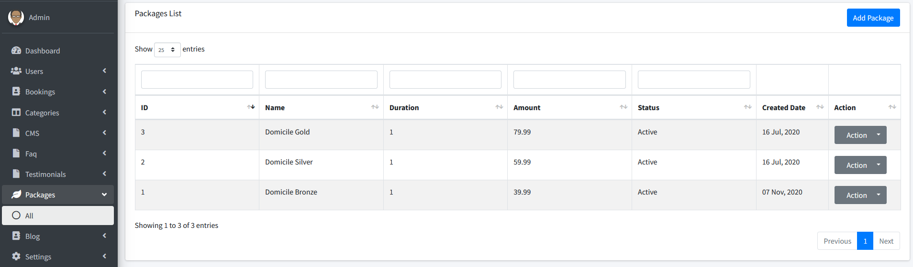
- There is nowhere to see the people who are connected and/or logged in to the site in real time.
- It doesn't have chat for help or to ask questions in real-time. Don't wait for a reply email.
- There is no way to manage the Admin user, change password, data, etc., it does not allow you to create another type of user that is not user or professional, I mean users with administrative power or with functions operator of the site and things like that.

- In the user profile when you select Support, I assume that you send an email to some predefined site, also the same or similar error as when creating a new user. I think it should also be sent to an admin user or an operator user dashboard, in addition to being emailed

- From what I see all finished work, photo uploads, etc. must be done by the apk, because on the page it does not allow it, I don't see where to differentiate or indicate that I as a user am an expert or just a user who is looking for a contractor.
- When changing the role of a user from user to professional or vice versa, an error jumps.
- 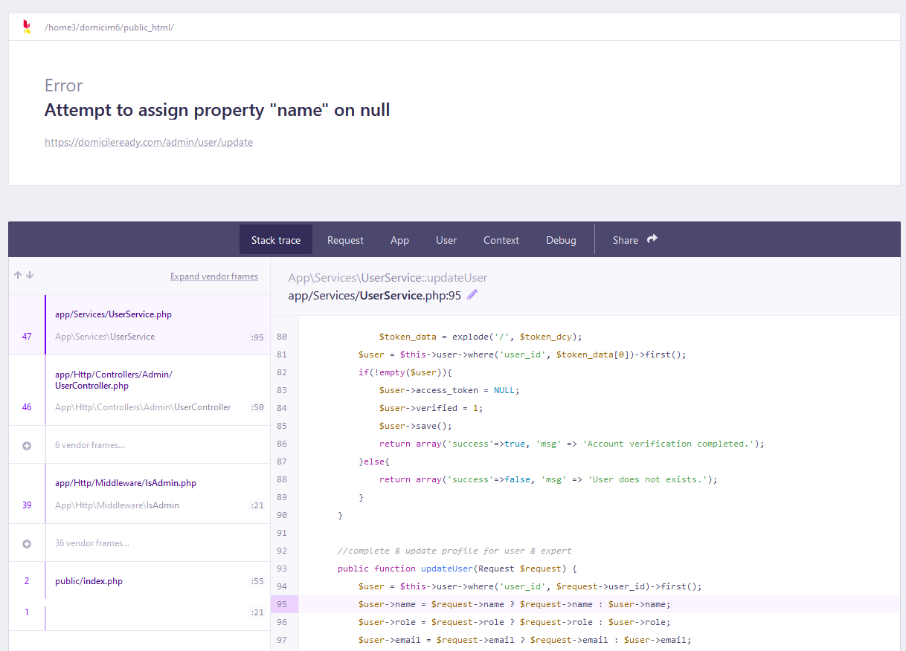23. We share the idea that we need to find a clearer way for the user to understand how to become a User or an Expert user, because it tends to confuse right now.
- The initial Dashboard that only shows user numbers is not updated. More information should be included in this Dashboard such as graphs, such as the number of jobs being done, the satisfaction of users (how many oks, how many oks, etc.), number of jobs completed, payments made, useful things that serve to see the status of the flow. Also, what the Dashboard has today is not updated.

-----------------------------Expert Profile--------------------------------
- As an expert, in the profile, when uploading a document it does not show a preview or at least it does not show a broken icon icon.
- It's not a mistake, but there must be a check that the information that is entered on a label is valid, or at least on the most important ones, such as account numbers, and things like that, I mean that if they are only numbers do not put letters.
- Maybe in the apk it will come out, but on the website you don't see in the Expert Dashboard any information about jobs that are on offer or maybe that will come out when you buy a plan, in Bookings of the Expert Profile.
- How does the expert user change the password? There must be confirmation for this change, as explained in the user part. Yes, the same story as the other user is when logging in but maybe we should add something else in the menu so that they can change the password.
- In My Expert Profile when you go to Profile a warning appears that until a plan is selected users will not see us as possible contractors for their jobs, when you start clicking on other options, this message disappears and is not seen again, this can tend to confuse, it must be permanent until the payment is made, Perhaps even the user shouldn't be given so much freedom to change all profile information until they make an initial payment.

